|  |  |  |  |
| --- | --- | --- | --- |
| **CS102** | **Fall 2020/21** | Project Group | 1A |
| Instructor: | **Uğur Güdükbay** |  |  |
| Assistant: | Assistant's Name |  |  |

|  |  |  |
| --- | --- | --- |
| **Criteria** | **TA/Grader** | **Instructor** |
| Presentation |  |  |
|  |  |  |
|  |  |  |
|  |  |  |
| Overall |  |  |

~ Sustainability Coach ~

SavioursoftheGreenWorld

Özgür Göker,Batuhan Balaban, Murat Ertan

|  |
| --- |
| Detailed Design Report  ( Version I )  3 December 2022 |

# Introduction

Sustainability coach is a program aiming to the users keep track of their sustainable habits by enabling them to record achievements given by the program. Our program has a website-like interface which requires signing up and signing in for further actions. After the login, the player will record the things they have done on the achievements page. On the news page, we can see the highest-ranking players. In the profile section, the player can update and maintain their information. In this document, we would like to extend the classes we will use and our final product environment. We have shrunk some features of our planned program as we have lost some team members along the way.

# Details

## Functioning

When a player starts the program, they will have to login using their name and surname with their password. Note that players with the same name and surname are different players given their passwords are different. No email verification for this project.

When the player interreacts with achievements, they will create an interaction object which will be stored on this player’s achievements list in their player object. In this way, all the data unique to the player will be stored, which could be followed by this player. The Statistics class will hold all the users and calculate rankings given each player interreactionScore. This class will also calculate the time difference to develop a time-based hypothesis. All the generated data from the statistics class will be displayed in the GUI news section. Note that those classes do not hold GUI details as the GUI itself will adjust such. The Player class may hold the profile page image, but this is optional for now.

## Solution Architecture

By storing all the player interactions, the program will come up with rankings and conclusions which will incentivise the players.

## Technologies and Environments

* We are using UMLET for UML diagram generation and viewing
* We are using APACHE NETBEANS IDE for GUI
* We are using SQLite for data management

## Core Classes and Responsibilities

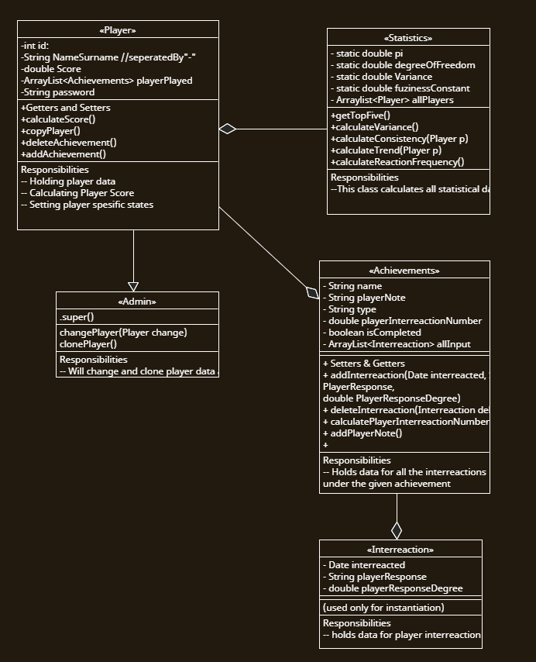

Given classes will process the player input collected from GUI. GUI classes are not listed here as they have been in the GUI report. As we have lost two members, responsibilities are distributed as follows:

* Özgür Göker: // Fill in the Blanks
* Murat Ertan: Statistics
* Batuhan Balaban: // Fill in the Blanks

# Summary & Conclusions

Henceforth, we can conclude that Sustainability Coach is a tracker for sustainable habits. What is more important is it could be extended with NLP recognition and level adjusting etc. It is a diary that helps keep track of sustainable practices and makes the player more aware of their occupation.